Multiple Linear Regression Mathematical Formulation From Scratch
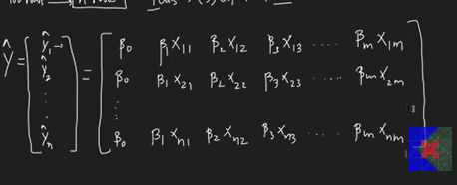
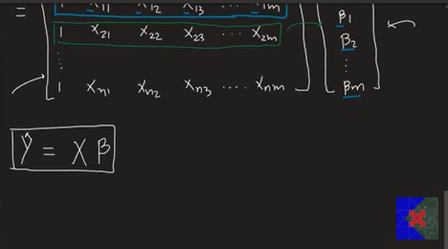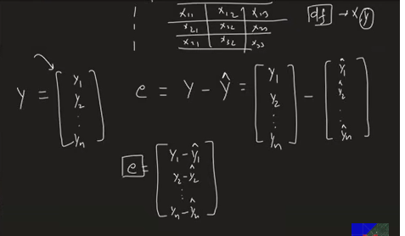
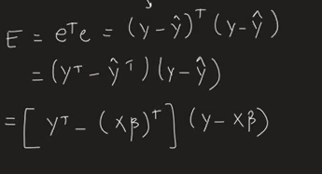
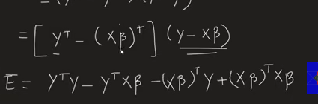
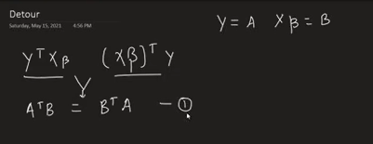

What is Multiple Linear Regression?
Multiple Linear Regression is an extension of Simple Linear Regression.
- Simple Linear Regression: One input feature predicts one output.
- Multiple Linear Regression: Multiple input features predict one output.

Example
Predicting Salary using
- CGPA
- IQ
- Experience
Here,
Input Features (X):
CGPA
IQ
Experience

Output (Y):
Salary

Mathematical Equation
If there are m features,
ŷ = β₀ + β₁x₁ + β₂x₂ + β₃x₃ + ... + βₘxₘ
Where
ŷ = Predicted value

β₀ = Intercept (Bias)

β₁, β₂, ... βₘ = Coefficients (Weights)

x₁, x₂, ... xₘ = Features

Goal of Linear Regression
Our goal is to find
β₀, β₁, β₂, ..., βₘ
Once these values are known, prediction becomes easy.
Example
ŷ = 5 + 2x₁ + 4x₂ - x₃
Just substitute x values to obtain prediction.

Dataset Representation
Suppose
- n = Number of students
- m = Number of features
Then the dataset becomes
n rows × (m+1) columns
Example
CGPA | IQ | Gender | Salary
8.2 | 120 | 1 | 8
7.5 | 110 | 0 | 6
9.0 | 135 | 1 | 10

Prediction for One Student
For first student
ŷ₁ = β₀ + β₁x₁₁ + β₂x₁₂ + β₃x₁₃
For second student
ŷ₂ = β₀ + β₁x₂₁ + β₂x₂₂ + β₃x₂₃
For nth student
ŷₙ = β₀ + β₁xₙ₁ + β₂xₙ₂ + β₃xₙ₃
Instead of writing these equations separately, we use Matrix Notation.

Matrix Representation

Predicted Output Matrix
| ŷ₁ |
| ŷ₂ |
Ŷ = | . |
| . |
| ŷₙ |

Feature Matrix (X)
The first column is always 1 because of β₀.
|1 x11 x12 ... x1m|
|1 x21 x22 ... x2m|
X = |. . . . |
|1 xn1 xn2 ... xnm|

Beta Matrix
|β₀|
|β₁|
β = |β₂|
|. |
|βₘ|

Matrix Equation
Instead of writing long equations,
we simply write
Ŷ = Xβ
This is one of the most important equations.

What does each matrix represent?

X
Contains all input features.

β
Contains all coefficients.

Ŷ
Contains predicted outputs.

Actual Output Matrix
|y₁|
|y₂|
Y = |. |
|. |
|yₙ|

Error (Residual)
Prediction is never perfect.
Residual means
Residual = Actual − Predicted
Matrix form
e = Y − Ŷ
Since
Ŷ = Xβ
Therefore
e = Y − Xβ

Loss Function
The model tries to minimize the error.
Residuals can be positive or negative.
Therefore we square them.
Loss Function
J(β)=Σ(yi−ŷi)²
This is called
Sum of Squared Errors (SSE)

Matrix Form of Loss Function
J(β)=(Y−Xβ)ᵀ(Y−Xβ)
This is the Multiple Linear Regression cost function.

Expanding the Cost Function
Using matrix algebra,
J(β)=YᵀY−2YᵀXβ+βᵀXᵀXβ

Objective
We want minimum loss.
Therefore
Take derivative
∂J(β)/∂β = 0

Derivative Result
After differentiation
−2XᵀY + 2XᵀXβ = 0
Move terms
2XᵀXβ = 2XᵀY
Cancel 2
XᵀXβ = XᵀY
Multiply inverse on both sides
(XᵀX)⁻¹XᵀXβ=(XᵀX)⁻¹XᵀY
Since
(XᵀX)⁻¹(XᵀX)=I
We get
β=(XᵀX)⁻¹XᵀY

Normal Equation (Final Formula)
This is the most important formula.
β=(XᵀX)⁻¹XᵀY
This directly calculates all coefficients.
This method is called
Ordinary Least Squares (OLS).

After Finding β
Prediction becomes
Ŷ = Xβ

Matrix Shapes
Suppose
n = Number of rows

m = Number of features
Then
X
n × (m+1)

β
(m+1) × 1

Y
n × 1

Xᵀ
(m+1) × n

XᵀX
(m+1) × (m+1)

Important Matrix Properties

Transpose
(A+B)ᵀ=Aᵀ+Bᵀ
(A−B)ᵀ=Aᵀ−Bᵀ
(AB)ᵀ=BᵀAᵀ

Inverse
AA⁻¹=I
Where
I = Identity Matrix

Why Do We Add a Column of 1's?
Original Data
CGPA IQ Experience
Becomes
1 CGPA IQ Experience
The extra column of 1's allows the intercept term β₀ to be learned using matrix multiplication.

Why Square the Errors?
Without squaring,
Positive and negative errors cancel each other.
Example
5

-5
Total
0
Which is misleading.
Squaring makes all errors positive.

Why Use Matrix Form?
Instead of solving hundreds of equations,
One matrix equation solves everything.
It is
- Cleaner
- Faster
- Easier for computers

Limitation of OLS
The Normal Equation
β=(XᵀX)⁻¹XᵀY
requires calculating the inverse matrix.
Finding an inverse is computationally expensive.
Time Complexity
O(n³)
for matrix inversion.
For datasets with thousands of features, OLS becomes slow.

Solution
Instead of OLS, use
Gradient Descent
Gradient Descent does not compute the inverse matrix.
Instead, it updates coefficients gradually.
Update Rule
β = β − α(∂J/∂β)
Where
α = Learning Rate

OLS vs Gradient Descent
OLS (Normal Equation) | Gradient Descent
Closed-form solution | Iterative solution
Gives exact coefficients | Gives approximate coefficients
Fast for small datasets | Better for very large datasets
Needs matrix inverse | No matrix inverse
Complexity increases with features | Scales well to high dimensions

Frequently Asked Exam Questions
Q1. What is Multiple Linear Regression?
A technique that predicts one dependent variable using two or more independent variables.
Q2. What is the equation of Multiple Linear Regression?
ŷ = β₀ + β₁x₁ + β₂x₂ + ... + βₘxₘ
Q3. What is the Normal Equation?
β=(XᵀX)⁻¹XᵀY
Q4. What is OLS?
Ordinary Least Squares is the method used to calculate coefficients by minimizing the sum of squared errors.
Q5. Why is Gradient Descent preferred for large datasets?
Because matrix inversion in OLS is expensive (O(n³)), while Gradient Descent avoids inversion and scales better.

Key Formulas to Memorize
ŷ = β₀ + β₁x₁ + β₂x₂ + ... + βₘxₘ
Ŷ = Xβ
e = Y − Xβ
J(β)=Σ(yi−ŷi)²
J(β)=(Y−Xβ)ᵀ(Y−Xβ)
J(β)=YᵀY−2YᵀXβ+βᵀXᵀXβ
∂J(β)/∂β=0
−2XᵀY+2XᵀXβ=0
β=(XᵀX)⁻¹XᵀY
Ŷ=Xβ
β=β−α(∂J/∂β)
These notes cover the complete mathematical intuition, matrix representation, derivation of the Normal Equation, and the comparison between OLS and Gradient Descent, making them suitable for exams, interviews, and revision.

